# Chime Scheduler

Chime Scheduler runs a PowerShell script on Windows at specified intervals. The included script plays a sound—hence the name “Chime”—but it can run any PowerShell script. The project offers two solutions:

1. Windows Desktop Application – Simple and user-friendly, providing core scheduling features.
2. Windows Task Scheduler – Offers greater customization and flexibility.

## Use Chime Scheduler Windows App

The app Chime Scheduler.exe can be found in the Chime Scheduler.zip root folder. It runs a PowerShell Script at a certain interval (in minutes).

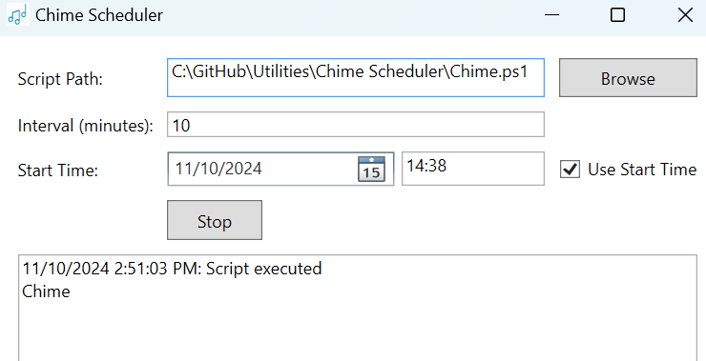

Users can minimize the application to a tray when it is running and wait in the background.

## Use Windows Task Scheduler

For more customized scheduling use Windows Task Scheduler to run the PowerShell script

1. Go to Task Scheduler
2. Select Action - Create Task - General
   * In Security options, select “Run whether user is logged on or not”
3. Go to Triggers and select New...
   * In settings select Daily,
   * In advanced settings, check Repeat task every 1 hour for a duration of 12 hours.
   * Click Ok.

1. Go to Actions and select New...
   * In Settings - Program/script, type powershell.exe
   * In Settings - Add arguments, type -WindowStyle hidden -File C:\path\to\HourlyChime.ps1
     + -WindowStyle hidden hides the powershell window
2. Go to Settings
   * Check Run task as soon as possible after a scheduled start is missed

## Chime.ps1

The ps1 script plays a sound file locating at 'C:\Windows\Media\Alarm03.wav'. Change the sound file location in the file as desired.